**Logging using SLF4J**

**Exercise 1: Logging Error Messages and Warning Level , Write a Java application that demonstrates logging error messages and warning levels using SLF4J**

**1.LoggerExample.java**

package com.example;import org.slf4j.Logger;import org.slf4j.LoggerFactory;public class LoggerExample { private static final Logger logger = LoggerFactory.getLogger(LoggerExample.class); public static void main(String[] args) { logger.error("This is an error message"); logger.warn("This is a warning message"); logger.info("This is an info message"); logger.debug("This is a debug message"); }}

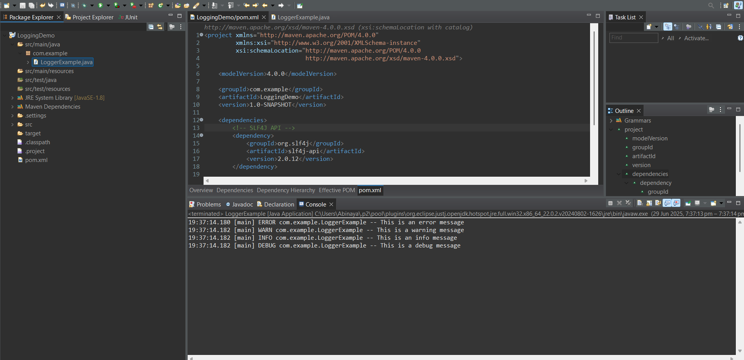**Output:**